**6. Neutron detector NEURAD**

*Introductory words*

The neutron detector NEURAD (NEUtron RADioactivity) is aimed at providing precise information on angular correlations of decay neutrons with a charged fragment, which is used to measure the decay energy and derive the corresponding life time value of exotic nuclei. High angular resolution is essential for this kind of measurements. Details of the intended realization of the NEURAD detector for the EXPERT project are discussed in this chapter.

**6.1 Requirements to the neutron detector**

The necessary angular resolution of the neutron detectors should be ~0.1 mrad. The detection threshold for the recoil proton should be not higher than 500 keV. The angular range covered by the detector is supposed to be ~+- 6 mrad. Such a small angular range reflects low transfer momentum, corresponding to the decay energy expected at the level of 1 keV (or 0.1-100 keV?)[ “Lifetime and fragment correlations for the two-neutron decay of 26O ground state” L.V. Grigorenko, I.G. Mukha, and M.V. Zhukov, **Phys. Rev.** **Lett.** **111** , 042501 (2013)].The simulated angular correlation of a neutron with the charged heavy recoil fragment is shown in the fig.. for the decay energies of 20 keV and 150 keV.



Figure. Monte Carlo simulations of the angular distributions between the heavy fragment and one of the neutrons for decay energies of 20 keV (solid curves) and 150 keV (dashed curves): (a) spectra for the true 2n decay of 26O; (b) spectra for the true 4n decay of 28O. The dash-dotted curve in (b) refers to a sequential 2n-2n decay of 28O via the 26O g.s. with 4n- and 2n- decay energies of 150 and 20 keV, respectively.

The efficiency of detection of a single intermediate-energy neutron with the proton-recoil energy above the ~500 keV threshold should be bigger than 50%. Sufficiently high granularity should allow to detect multiple neutron decays. The detector should provide time resolution of 300ps (FWHM) in order to allow correct event building. Background counting rate should be less than 1 Hz per channel.

**6.2 Operational principle of the fiber neutron detector**

Multichannel detectors based on scintillating fibers are widely used for charged particle tracking, e.g. [FT-examples]. In those applications fibers are oriented more or less (не точно!) perpendicularly to the particle trajectories. We are going to use scintillating fibers for detecting recoil protons in (*np*) scattering. In order to provide sufficient efficiency of detection and fine resolution, the fibers should be oriented in parallel to the trajectories of neutrons. Feasibility of such a detector was demonstrated in [Riken13]. Operational principle of the fiber neutron detector is shown in the fig… A neutron with energy of~200- 800 MeV interacts with material of the fibers via different channels. The most intensive is (*np*) scattering. The recoil proton produces a scintillation flash inside the fiber and the light emitted within the full reflection angle propagates to the photomultipliers located at the both ends of the fiber. The time difference between the two PMTs’ signals allows to find the longitudinal coordinate of the neutron interaction along the fiber. The longitudinal coordinate serves for discrimination of multi-neutron events from the multiple hits of a single re-scattered neutron and for data plausibility tests. The fibers are grouped into bundles with square cross section. Each bundle is read out by a multi-anode photo multiplier tube (MA PMT). Thus the transversal coordinates of the interaction point are defined. The transversal coordinates are converted into direction of the neutron. A bundle of fibers together with two MA PMTs forms a module of the neutron detector. The best light capture efficiency with a minimum cross talk can be achieved with double cladding fibers and an extra-mural absorber, however appropriate painting of single cladding fibers allows to obtain a reasonable performance as well.

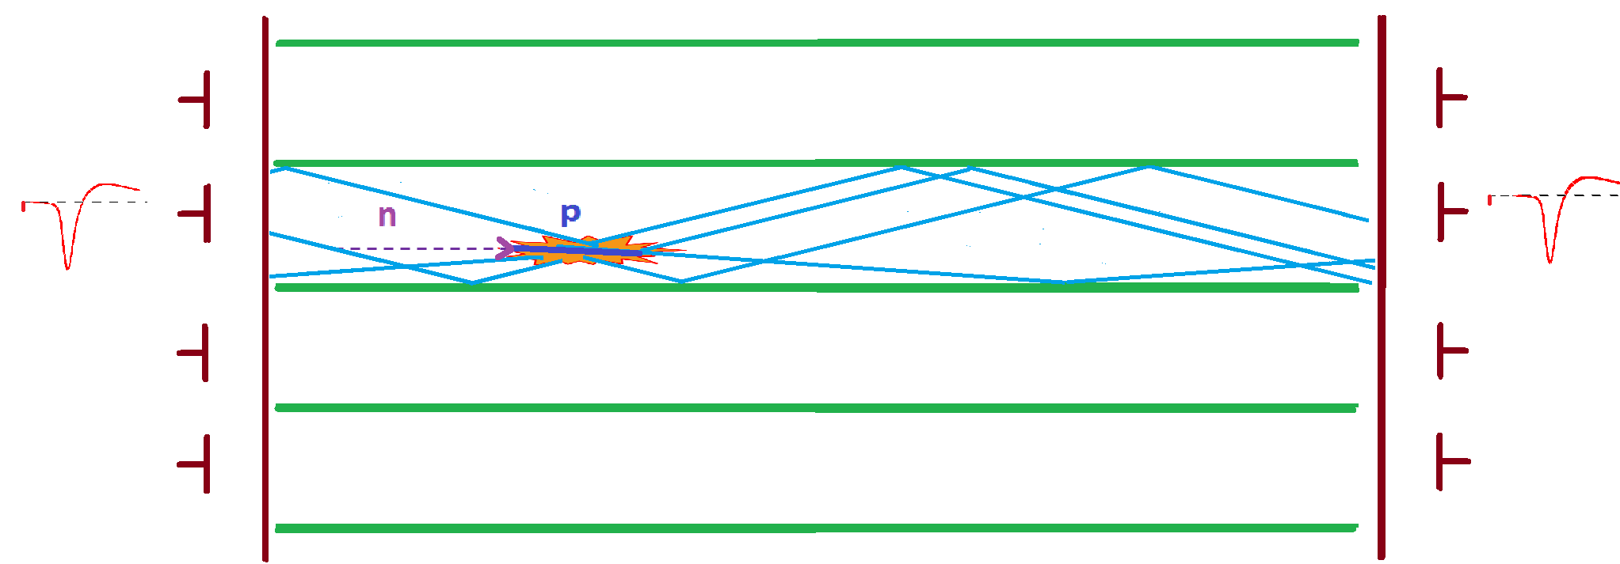

**6.3 Manufacturing a module**

Two types of modules are foreseen for the NEURAD detector. Both have the same mechanical dimensions and differ by the MA PMT used. The 3D model of a module is shown in the fig… The module consists of a bundle of 256 fibers with the square cross section of 3*3mm2 and two Hamamatsu MA PMTs of H10966 or H9500 type with a total area of 52*52 mm2 and the sensitive area of 49*49 mm2 fig. . Using MA PMT the transversal coordinates of the interaction point are defined

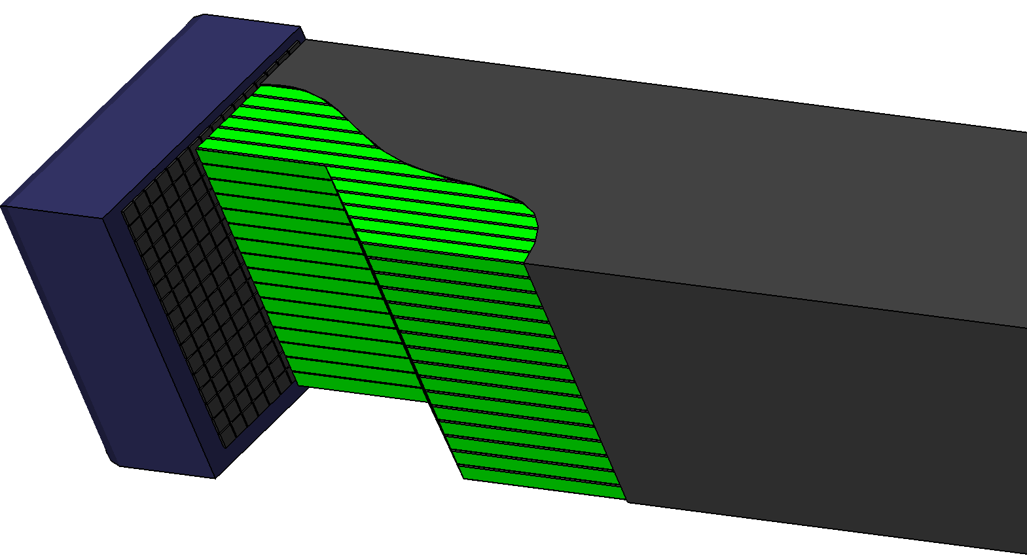

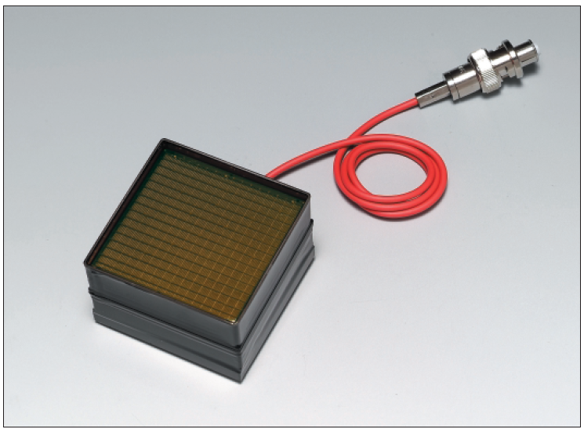

The module has a housing made of 0.2 mm thick Carbon Fiber composite. Single-cladding scintillating optical fibers BCF12 produced by Saint-Gobain have been chosen. Currently it is not possible to order a double cladding analogue because of environment protection restrictions imposed on the manufacturer.

Manufacturing of a module includes several stages: painting of the fibers, packing of a bundle, machining of ends of the bundle (to ensure good optical coupling with MA PMT) and assembling of a module. For about a half of the fibers, the first three steps can be ordered from the manufacturer of the fibers. For another half which is already delivered to GSI, those steps must be realized in the laboratory conditions.

* Painting the fibers.

A number of tests with different painting methods were performed in order to find a feasible solution [muk14a]. All the methods allow to reach the desired threshold of detection. The best time resolution can be achieved if the fibers are painted black on the lateral surface, even though light yield is reduced.

The painting procedure has certain peculiarities. Two painting layers are to be used. The first one is a white paint which should not interfere with a cladding material but stack on its surface. Acryl water-based paint suites well for such a purpose. The second paint layer should be black to ensure a small cross-talk of light between individual fibers. The resulting layers must be stable during the next procedures of packing and machining of the whole fiber bundle.

* Packing of a bundle and machining of its ends

The fibers should be assembled into a bundle rather precisely. Tolerable gaps between the neighboring fibers should not exceed 100 microns. It can be achieved using special mold for packing the fibers and gluing them with epoxy double-component glue. The mold is shown in the fig…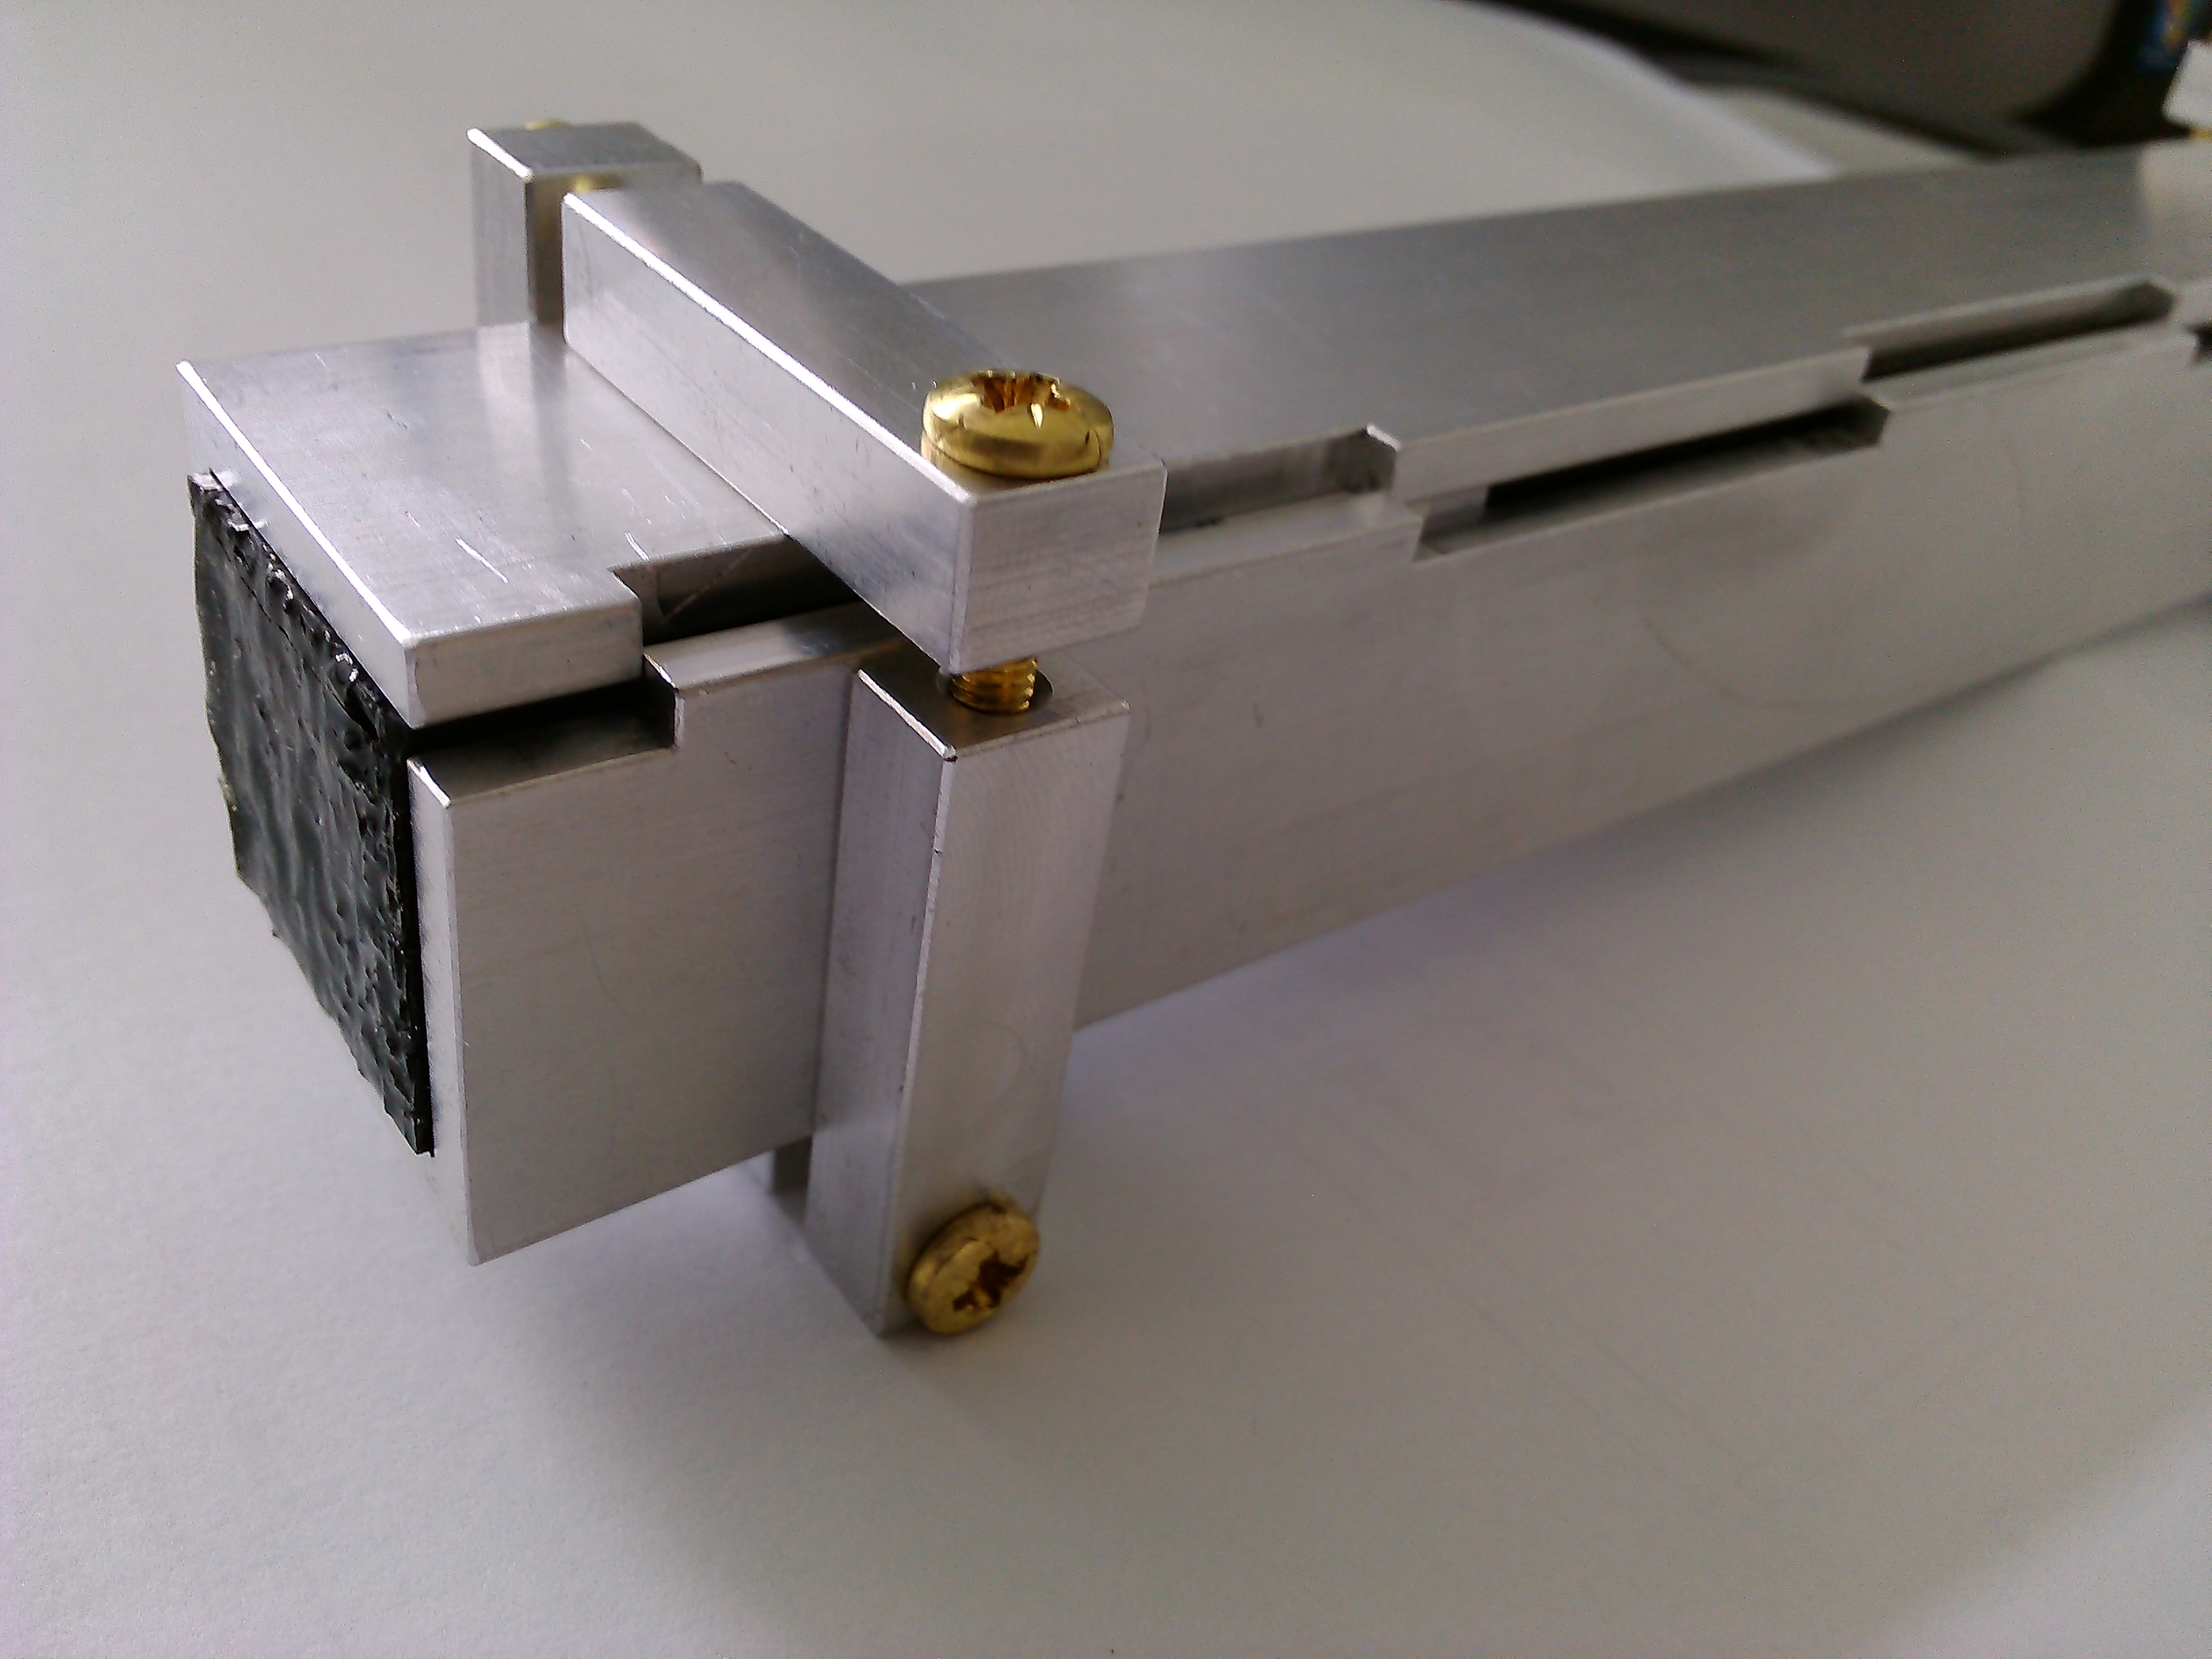

When a bundle is formed, it should be finely cut by using a diamond tool. Such a process is recommended for the best optical coupling between fibers and MA PMTs by the fiber producer Sain-Gobain. Finally, the bundle must be wrapped by a soft protecting band and a light-protecting cover which may be a carbon fiber composite box with walls of 0.2 mm. A prototype bundle prepared for further mounting is shown in the fig ?.

* Assembling of a module

The prepared bundle of fibers must be attached to two MA PMTs. Optical grease (e.g. BICRON BC-630) must be applied for optical coupling. Plastic rings/bands should keep the bundle and the MA PMTs together. In total, 6*6=36 such modules must be produced.

**6.4 Tests of the prototypes**

Several prototype modules were tested. Each one consisted of 64 fibers assembled into a 8 x 8 bundle whose end has been glued by epoxy glue and polished by using a diamond tool. The tests of the prototype light outputs and readouts have been performed by using gamma-ray sources and are described in [I.Mukha and D.Kulik, “Tests of scintillation Fibers for the compact neutron Detector NeuRad”, GSI Scientific Report 2013, in print]. We have tested multi-clad fibers BCF12 (produced by Saint Gobain) whose dimensions of 2*2*250 mm3 allowed for a fine spatial resolution. We have assembled three samples of the fibers: (i) without additional painting of fibers, (ii) with a white paint on each fiber in order to prevent a light cross-talk between the fibers, and (iii) with a black paint. Each sample consisted of 64 fibers assembled into a 8*8 bundle whose ends have been glued by epoxy glue and machined by using a diamond tool.

The test setup consisted of the fiber bundle viewed by the PMT Hamamatsu R7600 followed by the fast amplifier, the 5 GHz digital oscilloscope with the spectroscopic functions, and the sources of gamma-rays, 137Cs and 60Co (with the energies of 662 and 1332.5 keV, respectively). The light flashes caused in fibers by the Compton-scattered gamma- rays were converted into the electrical signals, amplified and directed into the oscilloscope where the signal traces and derived amplitude spectra were accumulated. All spectra had the shapes typical for Compton effect, see e.g. fig…

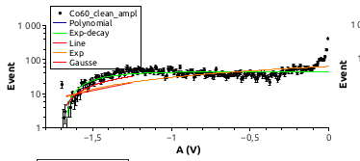

. The maximum energies of the Compton spectra (i.e. Compton edges) correspond to the respective maximal amplitudes of signals allowed to produce calibration curves for each sample, which is shown in Fig.... The values of maximal amplitudes *A* were obtained by fitting the spectra tails corresponding to the Compton edges. The obtained calibrations allow to find the detection thresholds for each fiber prototype. The amplitude range where the Compton effect disappears in the measured spectrum are shown by the grey area (see Fig…) whose highest value corresponds to the concluded threshold energy. The highest threshold value is in the black prototype, of ~160 keV. Taking into account the quenching of light yield (by the factor of 3) produced by protons in comparison with electrons of the same energy (the Birks’ low), the lowest-measured energy of protons scattered by incident neutrons should be ~500 keV. Such energy deposition should correspond to about 1300 photons, as the optical fibers BCF12 have the light output about 8000 photons/MeV. The quantum efficiency of the MA_PMT is about 37 %. Besides, the square fibers have trapping efficiency of about 7.3 %. Therefore we estimate the number of the photoelectrons corresponding to the detection threshold of 160 keV as~35.

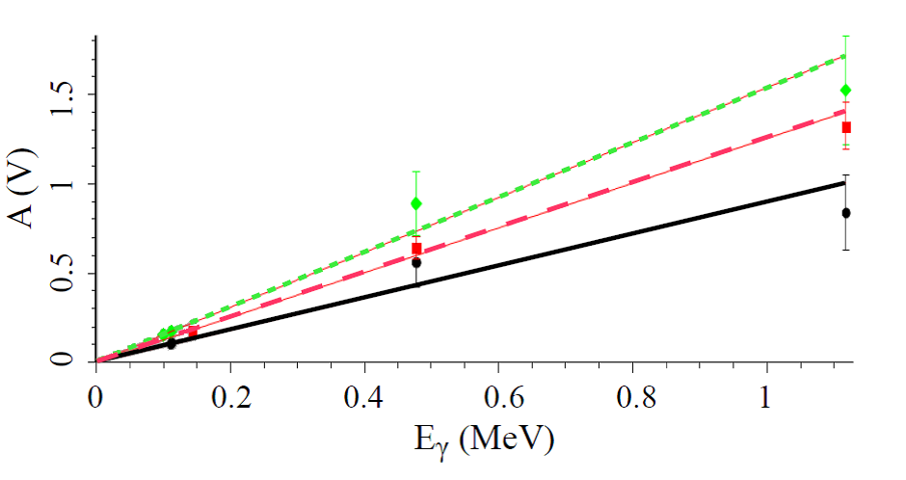

The calibration curves for all prototypes of the fibers scintillation detector NeuRad. The solid, dashed and dotted lines correspond to the black-painted, white-painted and not-painted prototypes, respectively. The grey area shows the threshold value of gamma ray detection.

Another prototype was prepared with a 8x8 bundle of white painted 3x3 mm single cladding fibers

Описать новые тесты

**6.5 Detector layout and positioning**.

The NEURAD detector is supposed to be placed at the distance of 26 m from the target located in the FMF2 intermediate focal plane of the Super-FRS. Desirable acceptance will be achieved using an array of 36 modules. The layout of the detector is shown in the figure ??. The modules with fine granularity are shown in dark green and those with coarse granularity - in light green.

Positioning of the NEURAD detector at Super-FRS is depicted in the figure ?? One can see that there is sufficient space for the detector itself and necessary services.

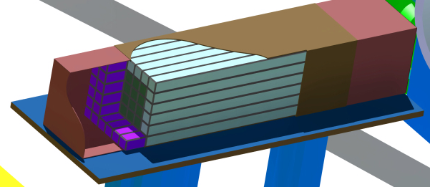

**6.6 Readout**

To be written

**6.7 Powering scheme and services**

To be written

**6.8 Background rejection concept and expected performance**

Neutrons and gamma-rays produced by incident radioactive beam in a secondary target will cause the background counting. The expected background rate is low because production rate of the neutron precursors is rather low, of the order of few nuclei per second. The background rejection will be made by demanding time correlated registration of a projectile nucleus (identified by its charge and mass measured by standard Super-FRS detectors), identified heavy decay fragment and an event in the NeuRad. All three sub-events should occur within narrow time ranges defined by the time of flight. Further background rejection will be done by selecting strong angular correlations of the heavy fragment and the NeuRad sub-event which corresponds to neutron decays with very small decay energy of 1 keV.

**6.9 Operational environment**

There are two potentially risky environmental factors, the radiation conditions and magnetic fields from magnets. The compact MA PMTs used in NeuRad are not very sensitive to magnetic fields. As the closest dipole magnet is located at 7 m upstream the NeuRad, we expect that the corresponding stray field will be negligible. For the scintillating fibers of various types the radiation degradation of the optical properties becomes appreciable at the dose of few hundreds krad [RUCHTI96]. Radiation conditions at the SuperFRS are discussed in the section ?.?.? One can expect for NEURAD 2 years of operation without deterioration of the performance.